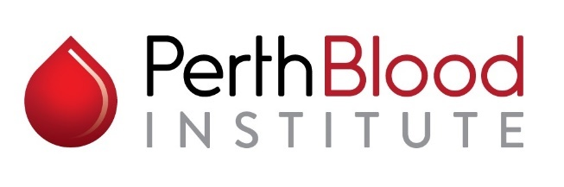

Clinical Research Fellowship

Part-time FTE 0.5 – 4 January 2021 to 31 December 2021
The Perth Blood Institute (PBI) conducts medical research into blood disorders, including their causes, prevention and treatment options; facilitates access to high quality clinical trials for people affected by blood disorders; and provides information about blood disorders to patients and their families.
PBI is pleased to call for applications for a PBI Clinical Research Fellowship to be taken up from 4 January 2021.
PBI is seeking a FRACP/FRCPA qualified, highly motivated and enthusiastic Haematology Fellow / new consultant Haematologist to join our thriving haematology and research practice. Our centre of excellence is co-located in West Perth alongside Western Haematology and Oncology Clinics and Western Diagnostic Pathology, and at Murdoch University. The successful applicant will work closely with our Clinical Trials Unit in coordinating and performing clinical trial and investigator-led research. Currently we have over 20 active clinical trials. There may also be an opportunity for additional clinical laboratory haematology consultation experience, depending on interest and circumstance.
There is also an opportunity to initiate and conduct your own investigator-led research and to pursue your private haematology practice to supplement this opportunity.
PBI Clinical Research Fellowship Priorities

Alignment with PBI vision and aims – to extend the lifespan and quality of life for those living with blood disorders

Able to combine research with clinical haematology role

Focus on optimising outcomes while ensuring exceptional clinical care to patients enrolled on clinical trials

PBI Clinical Research Fellowship Value
The Clinical Research Fellowship is funded to a total value of $55,000 for a period of one year only (at 0.5FTE).

PBI Clinical Research Fellowship Eligibility

Applicants must:
- Be able to take up the Fellowship from January 2021
- Be FRACP and/or FRCPA qualified in Haematology
- Be an Australian or New Zealand resident
- Provide regular progress reports to PBI
Applications:

Applications close on Friday, 16 October 2020 at 5:00 pm

Please forward a cover letter, CV and the names and contact details of 2 referees to:

Professor Ross Baker

Chair, The Perth Blood Institute

18 Prowse Street

West Perth WA 6005

For a copy of the position description please email Cate at cate@pbi.org.au. For further information contact Professor Ross Baker at Ross@pbi.org.au or on 0417 989 786 or visit the PBI website at www.pbi.org.au.

